Output file :
1)secure registration
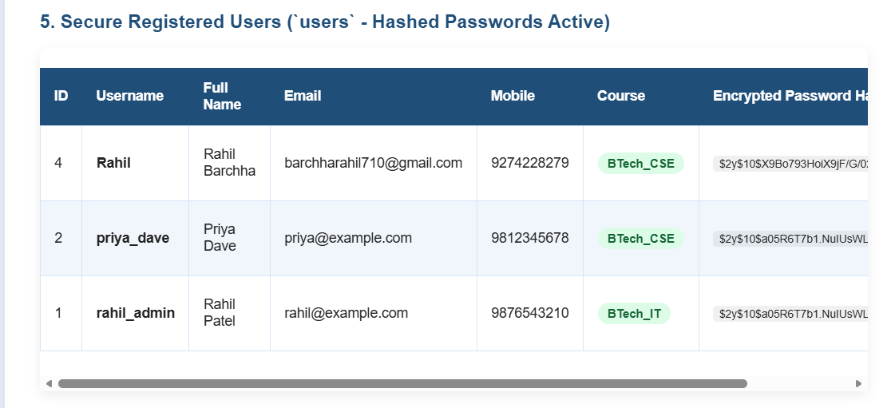

2)secure database updated
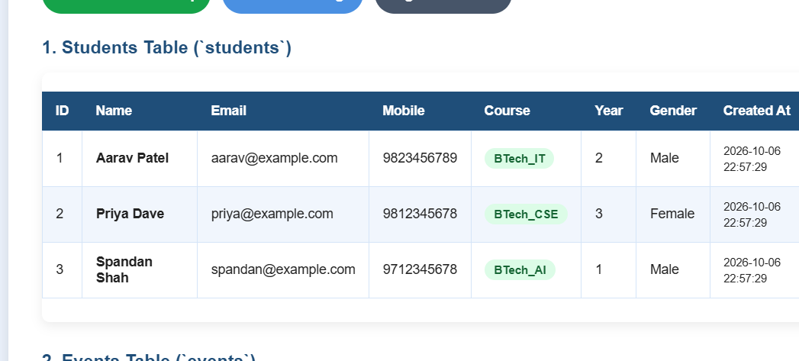
3)new entry stored

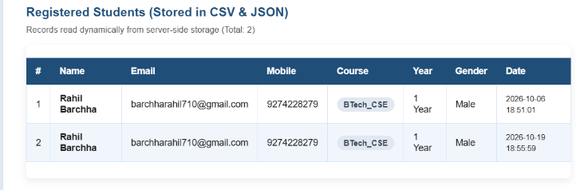
Github Link : https://github.com/Shreyansh2210/Web-Devlopment/tree/main

